**CHAPTER FOUR**

**RESULTS AND DISCUSSION**

**4.1 ANALYSIS OF RESULT**

**T**he sequential steps for the execution of the implemented application with their respective screen shots are shown below.

Configuration Implementation

**4.2 Lecturer**

To insert a new lecturer into the system, click the File menu then the Lecture Sub-Menu, next click the Add Lecturer Button at the Right Top side of the window then it will bring a new window that the information of the new lecturer will be filled up with.

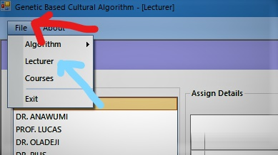

Figure 4.1 : Showing the Lecturer Menu

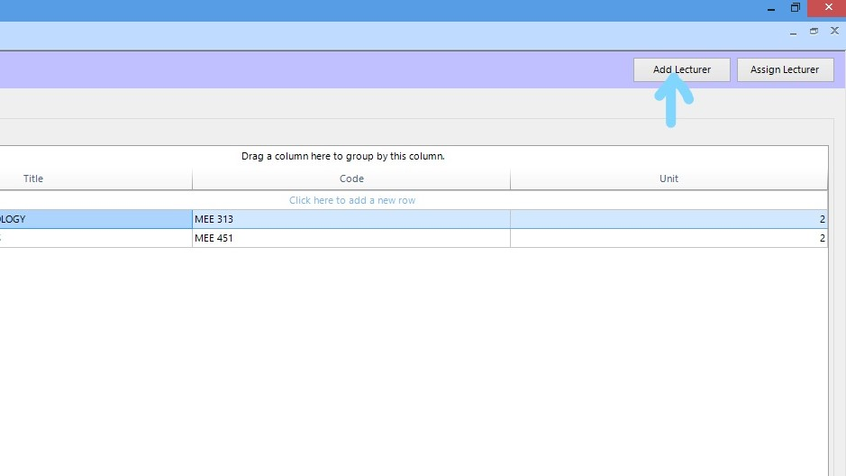

Figure 4.2 : Button to show the Add Lecturer feature of the system

To view the lecturers and courses assigned to them, click the lecturer menu from the File Menu

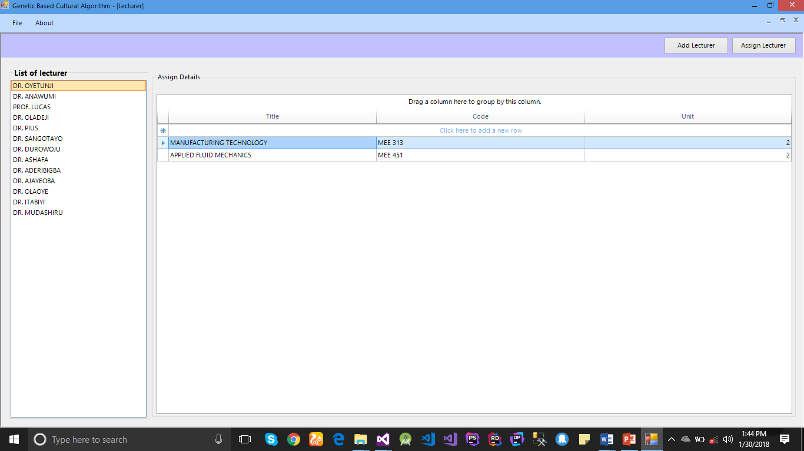

Figure 4.3 : Lecturer’s view with the details and course assigned.

**4.3 Courses**

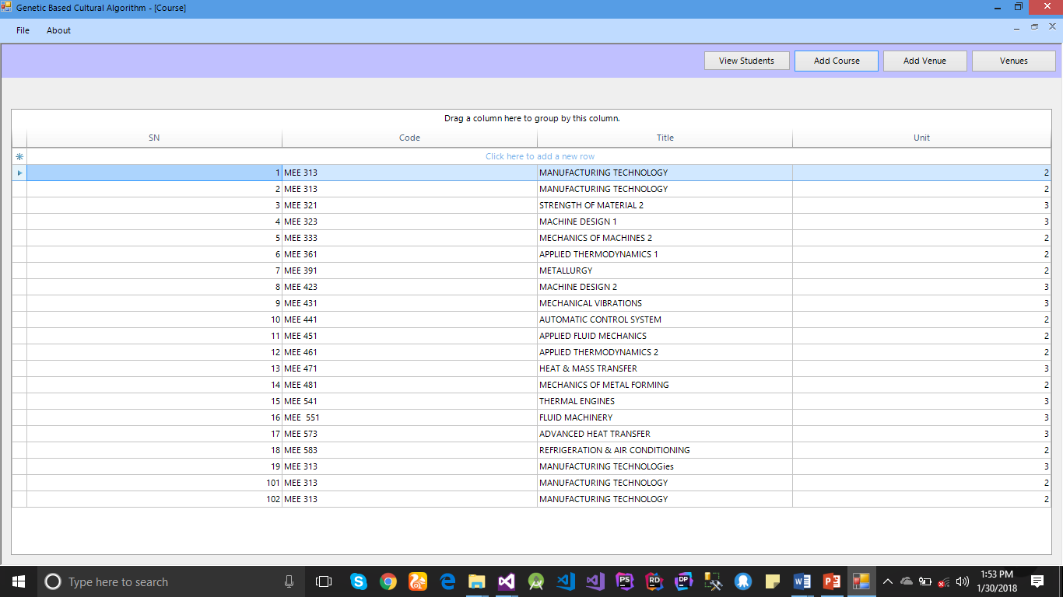To add course to the system, click the File menu then click courses menu, it will then show the view of all the courses, click the Add Course Button at the right hand side of the view to add details of the course then save and also click the Add Venues to save venues to the system.

Figure 4.4 : Courses View

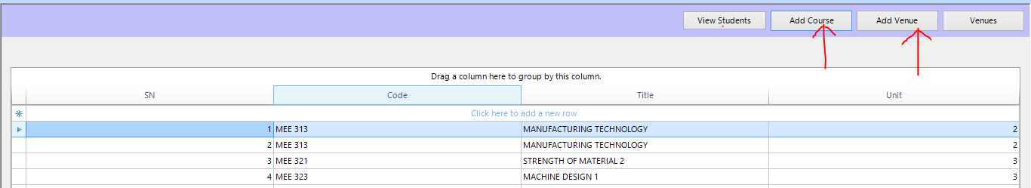

Figure 4.5 : Add courses and Venue Button

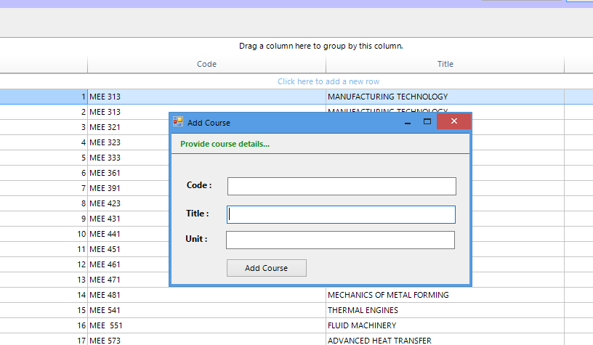

Figure 4.6 : Course View

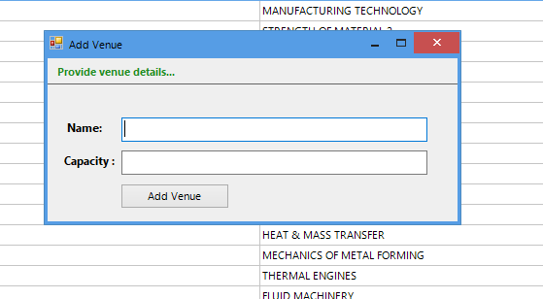

Figure 4.7 : Venue View



Figure 4.8 : Student Detail View

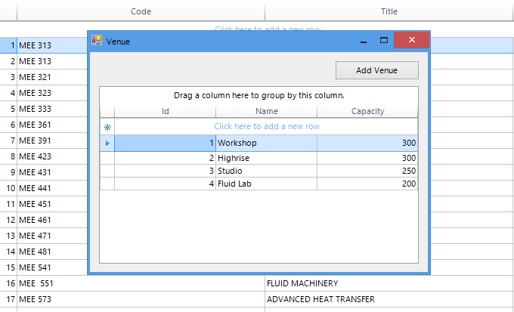

Figure 4.9 : Venue Detail View

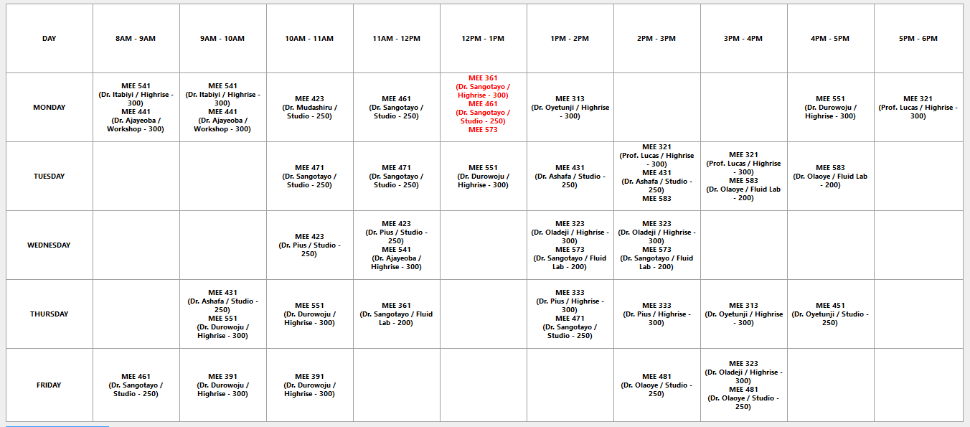Time Table Generated – First Iteration

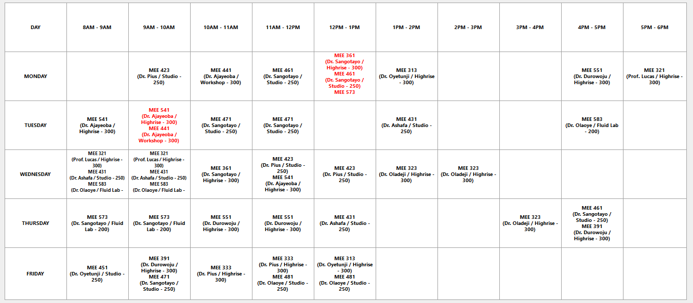Second Iteration

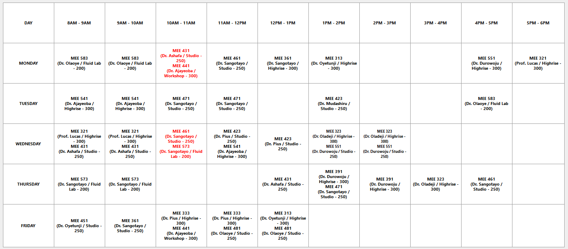Third Iteration

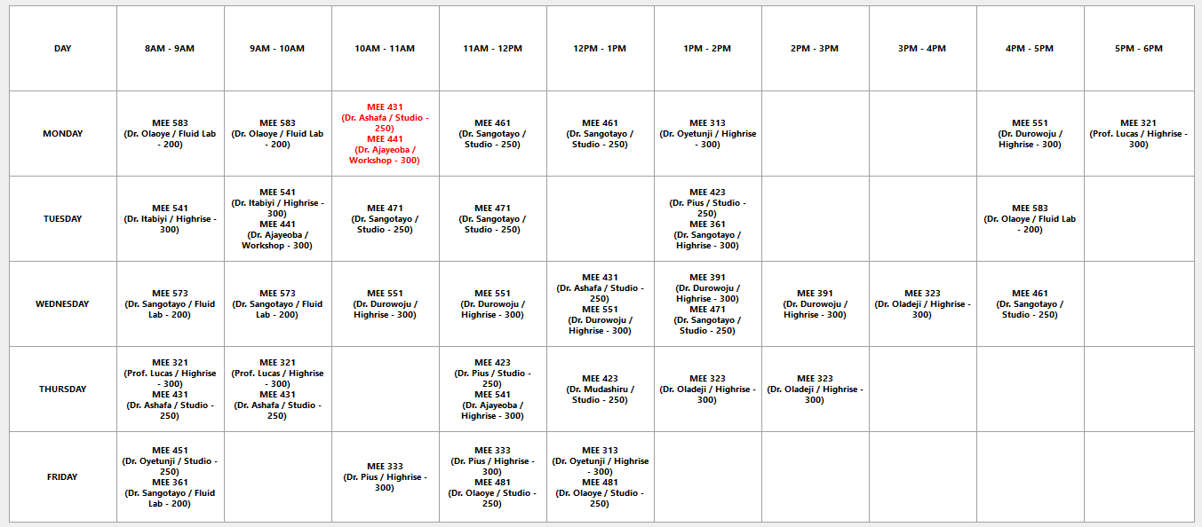Fourth Iteration

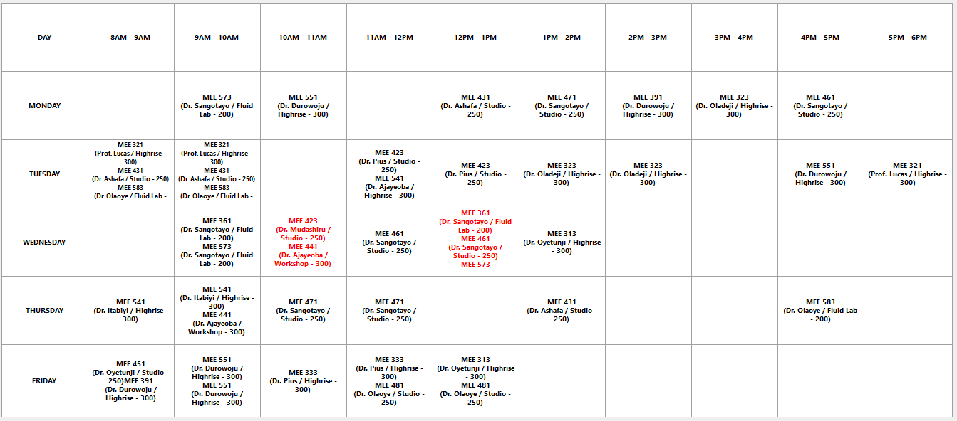Fifth Iteration

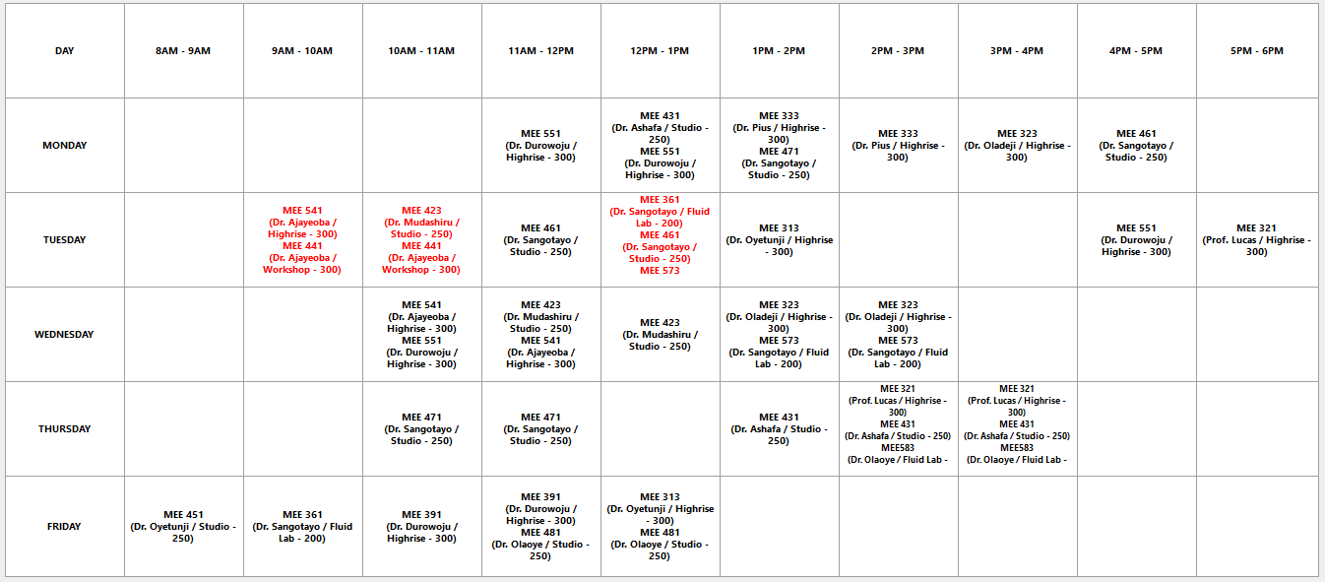Sixth Iteration

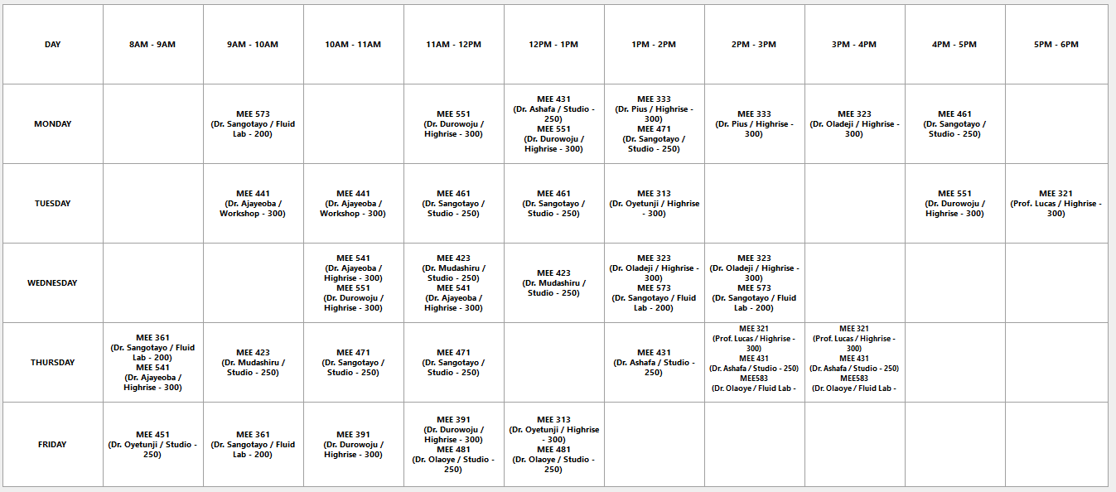Seventh Iteration

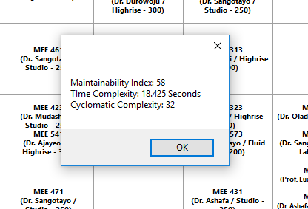

**Figure 4. 17: Result Analysis view**

**4.4 MAINTAINABILITY INDEX**

Maintainability index calculates an index value between 0 and 100 that represents the relative ease of maintaining the code. A high value simply means better maintainability. From the result shown in fig 4.17, the value of the maintainability index is **58**.

**4.5 COMPLEXITY ANALYSIS**

Time complexity and cyclomatic Complexity is shown in the fig 4.17.

**4.6 OUTPUT OF RESULT**

The result of the genetic-based cultural algorithm program is indicated below stating the different execution time (in secs) and the number of constraint violated for the first seven iterations.

**Table 4.2 Obtained Results**

|  |  |  |
| --- | --- | --- |
| ITERATION | Genetic-based Cultural Algorithm  (time in secs) | Number of Constraint  Violated |
| 1st | **18.923** | **4** |
| 2nd | **19.254** | **4** |
| 3rd | **14.209** | **3** |
| 4th | **16.402** | **3** |
| 5th | **17.238** | **2** |
| 6th | **16.444** | **1** |
| 7th | **16.433** | **0** |